

WOOW FOOD BUSINESS MODEL

Introduction
Woow Foods was established in August 2016 and operates in the food and hospitality industry. They are currently located in two Cape Peninsula University( CPUT) campuses’ student cafeterias, namely Mowbray and District Six. Mrs. Noxolisa Ndyalivani, the owner of Woow Foods, started the catering business to focus on providing healthy, tasty, and affordable food that reminds her customers of home. Many of the customers are originally from different provinces, therefore the aim is to make them feel at home while providing quality food. This is part of their competitive advantage as Woow Foods’ menu caters for each culture’s street food and plated foods at an affordable price. At the cafeteria she sells products such as gatsbys, kotas, vetkoek, chip rolls, sandwiches, light snacks and cold and hot beverages. In addition to the cafeteria restaurants, Woow Foods provides catering services for CPUT workshops, sports events, and any other events outside of the varsity. The catering services are usually needed from them on weekends for events outside of the varsity.

Sales: Sales are tracked using a POS system and they use MTN MoMo to track card payments. There is also a PC with loaded products at each store that gives reports on which products were purchased by customers throughout the day.
Expenditures: All the expenses of the business can be seen on their relevant financial statements and bank statements. SMTAX is the firm responsible for all their financial calculations and record-keeping. If Woow Foods requires any financial information, they can request it from them. There is also access to invoices from suppliers to analyse the prices of stock purchased.
How will the firm create value?
Woow Foods is currently selling different types of products ranging from gatsbys, vetkoek, kotas, sandwiches, chip rolls, snacks, soft drinks and traditional food. Woow Foods offers freshly prepared, home-cooked meals made on the same day of sale, ensuring customers receive warm, wholesome, and healthy food. The business also offers catering services to the Cape Peninsula University of Technology when they have sports functions or other events. Yet, Mrs Ndyalivani's main business is the cafeteria business. She has expressed that most of her sales come from customers purchasing kotas, vetkoek, chip rolls, and traditional meals. Mrs Ndyalivani does not have any combo packages but has considered creating some in order to generate more sales.

She has also considered introducing delivery services for customers such as lecturers as they have busy schedules, leading to them not having enough time to go to the cafeteria. Implementing the delivery service would turn lost sales into active sales and generate more income. Combo packages will help retain lecturers as customers because they prefer their meal with coffee or other beverages. The price would then usually be more affordable than buying the combo components separately so the business will essentially provide affordability. The delivery to lecturers saves the lecturers’ time while increasing sales. There will be more customers due to delivery but a shorter line and shorter waiting time for student customers. The value would then be catering to their needs/wants of affordability, ready-made combos, and shorter waiting times.

The revenue drivers for Woow Foods are diagramed below.

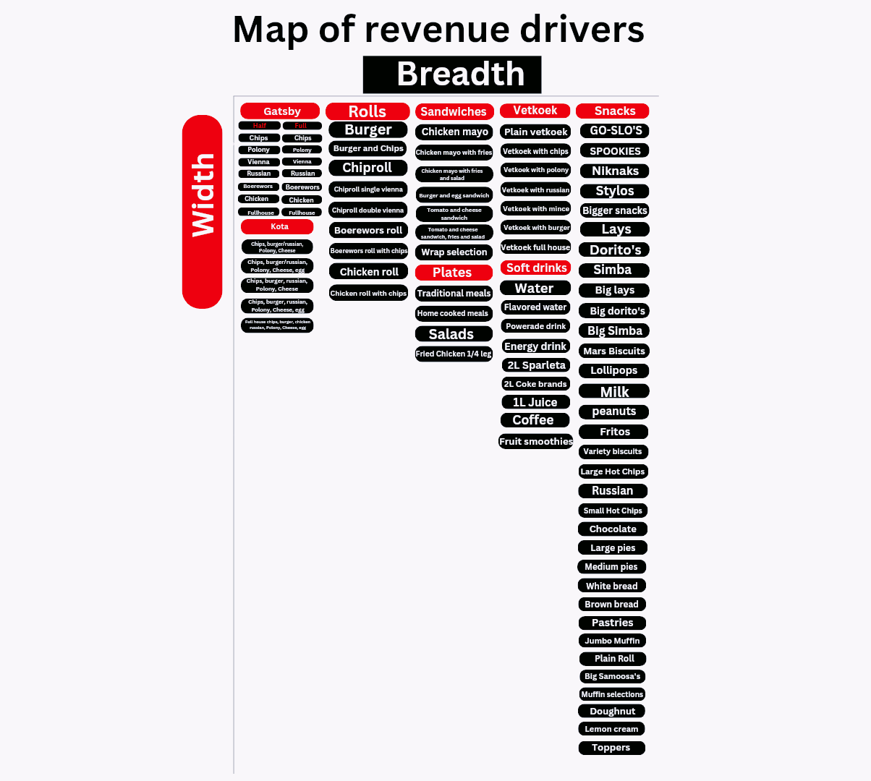

And below it is the Woow Foods store menu.

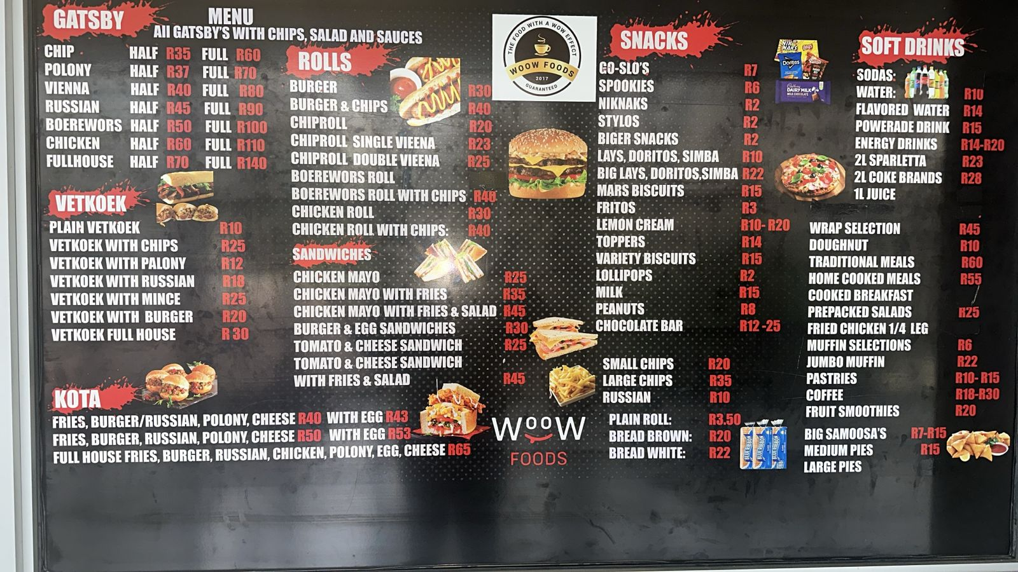

For whom will the firm create value?
Woow Foods currently only provides their services to the CPUT community, including the students, lectures as well as other staff members. However, Mrs Ndyalivani is open to expanding Woow Foods by opening other restaurants in different Universities such as University of Cape Town and University of the Western Cape, she has also considered providing delivery services around the Cape Town areas through Uber Eats. It is currently only operated in the Cape Town area, particularly in Districts 6 and Mowbray. Despite the fact that Woow Foods operates mainly in Cape Town, its clientele includes a variety of consumers from different areas across the country. Therefore we can say that it caters for a very broad market, especially considering the wide variety of food sold in the restaurant. Currently however, the main target market are CPUT students, lecturers and other employees.

What is the firm’s source of competence/advantage?
The source of internal competitive advantage for Woow Foods is Noxolisa's business experience and her passion for providing quality, healthy and affordable food options in the fast food market. Mrs Ndyalivani always ensures that she caters for her clients at all times, even when trends in the market change, she always finds ways to be up to date through creativity and sourcing opinions from her current customers. She manages positive relationships with all her clientele, to the extent where she even visits them in their offices or calls to check up on them. Her commitment to ensuring that her customers feel at home while serving them with the best quality of food at an affordable price already places her in a competitive advantage.

How will the firm differentiate itself?
Woow Foods will differentiate itself by positioning as a restaurant that not only offers healthy, affordable, and high-quality meals, but also creates a strong sense of community among its customers. Unlike other restaurants in the CPUT campuses, Woow Foods prioritises building long-term relationships with customers by ensuring every customer's needs are fully met, introducing specials, and consistently updating its menu to meet changing tastes and trends. By expanding into other universities such as UCT and UWC, as well as offering delivery services through Uber Eats, Woow Foods will be able to tap into a larger market while still maintaining its reputation for homely and customer centered experiences. Mrs. Ndyalivani’s experience, qualifications, and hands-on approach through checking in with customers personally, ensuring consistency in food quality and incorporating customer feedback with the suggestion box, gives Woow Foods a unique advantage. The mix of community engagement, menu variety, and affordability creates a brand identity that stands out in the fast food sector.

How will the firm make money?

Woow Foods operates on a dual-segment strategy, balancing medium-volume, medium-margin items like Gatsbys and Kotas with high-volume, low-margin offerings such as snacks and beverages. The business generates on average R60,000 per week in sales, though this drops significantly to around R25,000 per week during exam season, reflecting the high dependency on university foot traffic. This volatility highlights both the potential and the risks associated with a campus-centered operation.

The restaurant faces fixed costs of R33,560 per month (R23,560 for rent, water, and electricity, plus R10,000 in permanent staff salaries). On top of that, variable costs raw materials, packaging, and casual labor often exceed fixed costs, showing that the business is heavily driven by sales volumes. Despite these pressures, Woow Foods currently reports a net profit margin of 56.6%, which is outstanding for the fast-food sector. This strong performance is largely due to the exceptional markups on its flagship products.

More than 90% of total monthly revenue is derived from Gatsbys and Kotas, making them the backbone of the business. With markups of approximately 351% for Gatsbys and 252% for Kotas, these products generate both high volume and high margin, fueling profitability. Drinks and snacks, while operating at thinner margins, provide consistent add-on revenue, improving basket size per customer and stabilizing cash flows. Vetkoek, although fast-moving and attractive to price-sensitive customers, contributes only about 7% of revenue and is likely underreported due to cash transactions. This underreporting could mask its true contribution to the bottom line, meaning operational controls in this segment may need strengthening.

The overall picture reveals that Woow Foods thrives on a concentrated product mix, where two items Gatsbys and Kotas carry the financial weight of the business. While this concentration drives high profitability, it also introduces concentration risk. A downturn in demand for these products, or mispricing in their cost base, could quickly destabilize the company’s strong net margins. To safeguard its financial health, Woow Foods must not only sustain pricing discipline on its flagship products but also optimize margins on secondary products like vetkoek, snacks, and beverages to reduce over-reliance on two categories.

Figure 1: Volume and revenue

Product Category | Units Sold | % of Total Volume | Revenue | % of Total Revenue
Gatsbys | 800 | 57.1% | R88,000 | 66.6%
Kotas | 520 | 37.1% | R31,200 | 23.6%
Vetkoek | — | — | R9,800 | 7.0%
Drinks | 120 | 8.6% | R3,000 | 2.3%
Snacks | — | — | R1,300 | 1.0%
Total | 1,440 | 100% | R133,300 | 100%

Figure 2 : Cost Breakdown

Full Gatsby
Product name | Cost (R) | Selling (R) | Mark Up
Chips Gatsby | R34,30 | R60,00 | R25,70
Polony Gatsby | R36,80 | R70,00 | R33,20
Vienna Gatsby | R44,30 | R80,00 | R35,70
Russian | R61,30 | R90,00 | R28,70
Boerewors | R47,80 | R100,00 | R52,20
Chicken Gatsby | R53,80 | R110,00 | R56,20
Fullhouse | R98,80 | R140,00 | R41,20
Half Gatsby
Chips Gatsby | R17,15 | R35,00 | R17,85
Polony Gatsby | R18,40 | R37,00 | R18,60
Vienna Gatsby | R22,15 | R40,00 | R17,85
Russian | R30,65 | R45,00 | R14,35
Boerewors | R23,90 | R50,00 | R26,10
Chicken Gatsby | R26,90 | R60,00 | R33,10
Fullhouse | R49,40 | R70,00 | R20,60
Vetkoek
Plain Vetkoek | R4,00 | R10,00 | R6,00
Vetkoek with Chips | R13,00 | R25,00 | R12,00
Vetkoek with polony | R5,00 | R12,00 | R7,00
Vetkoek with russian | R17,50 | R18,00 | R0,50
vetkoek with burger | R7,50 | R20,00 | R12,50
vetkoek Fullhouse | R31,00 | R30,00 | -R1,00
Kota
Kota with russian | R36,60 | R40,00 | R3,40
Kota with Patty | R25,60 | R40,00 | R14,40
Kota with russian without cheese | R24,70 | R43,00 | R18,30
Kota with Patty without cheese | R23,80 | R43,00 | R19,20
Rolls
Burger | R33,60 | R30,00 | -R3,60
Burger with Chips | R37,60 | R40,00 | R2,40
Chiproll | R14,60 | R20,00 | R5,40
Chiproll with single vienna | R17,10 | R23,00 | R5,90
Chiproll with double vienna | R19,60 | R25,00 | R5,40
Boerewors | R39,60 | No price | #VALUE!
Boerewors with chips | R45,60 | R46,00 | R0,40
Chicken Roll | R16,60 | R30,00 | R13,40
Chicken Roll with chips | R25,60 | R40,00 | R14,40
Sandwitches
Chicken Mayo | R15,00 | R25,00 | R10,00
Chicken Mayo with Fries | R20,00 | R35,00 | R15,00
Chicken Mayo with Fries with salad | R27,00 | R45,00 | R18,00
Burger & Egg sandwich | R10,00 | R30,00 | R20,00
Tomato & Cheese sandwich | R7,00 | R25,00 | R18,00
Tomato & Cheese sandwich with fries and salad | R17,00 | R45,00 | R28,00

FIgure 3: PROFIT and EXPENDITURE BREAKDOWN
Monthly Revenue: Total = R133,300
Monthly Costs:
Ingredients: R9,263
Fixed Costs (Rent + Utilities): R23,560
Estimated Labour: R25,000
Total Expenditure = R9,263 + R23,560 + R25,000 = R57,823
Estimated Monthly Profit: R133,300 − R57,823 = R75,477
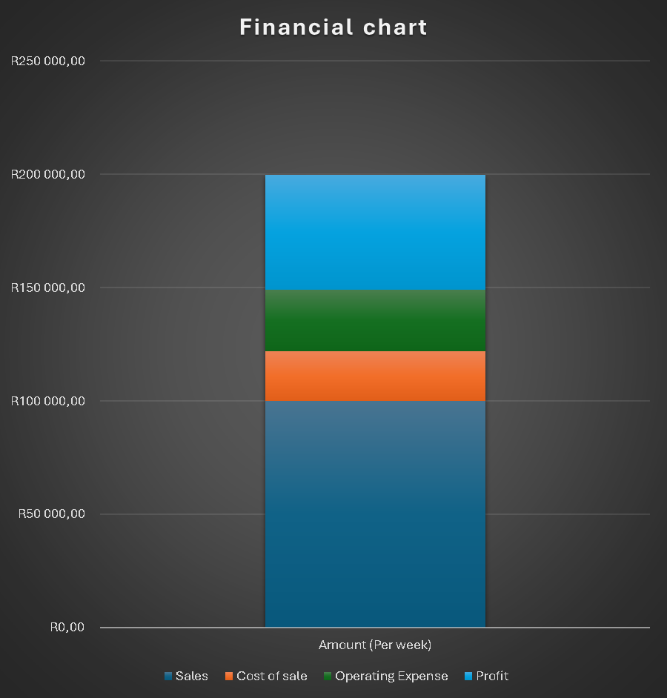
The financial chart illustrates the weekly performance of Woow Foods, broken down into Sales, Cost of Sales (COS), Operating Expenses, and Profit.
Sales: The business generated R99,937.55 in weekly revenue, which reflects strong customer demand, particularly from high-margin items like Gatsbys and Kotas. This forms the base of the chart, represented by the largest blue segment.
Cost of Sales (COS): The direct costs associated with producing food items, including raw materials and packaging, amounted to R22,094.98. This represents approximately 22.1% of total sales, which is an excellent ratio for a fast-food business. It shows that the company is effectively managing food input costs while maintaining significant markups.
Operating Expenses: Fixed and variable operating costs, including rent, utilities, and salaries, totaled R27,109.96 for the week. This accounts for 27.1% of sales, slightly higher than COS, which highlights that non-production overheads remain a significant component of weekly expenditure.
Profit: After subtracting both COS and operating expenses, the business achieved a net profit of R50,732.61, equivalent to a net profit margin of 50.7%. This margin is exceptionally high for the fast-food industry, where average net margins typically range between 8% and 20%. The high profitability is driven by strong markups on flagship products and consistent sales volume.

What are the Entrepreneur’s Time, Scope, and Size Ambitions?
Time: Mrs. Ndyalivani’s day typically starts around 5h30 when she wakes up and then gets herself ready for the day at 6h00. She then wakes up the kids at 6h20 and helps them get ready for school. At 6h40 she prepares their breakfast and packs their lunches. Between 7h00 and 7h10 they leave the house and she drops the kids off at school. Everything she does until she has dropped off the kids is considered idle business time. After she has dropped them, at 8h00, she immediately goes to buy her daily stock for the cafeteria. The first stop would be Bellville Atlantic and then she goes to Epping to buy fresh vegetables and some cold drinks. Between 9h30 and 10h00 Mrs. Ndyalivani would drive to the Mowbray campus to drop the stock off, check up on staff, check up on gas, as well as reviewing the plans for the day. After this, she usually drives to the Cape Town, District Six branch and arrives there between 11h00 and 11h30. She then drops off their stock, catches up with the chef, checks what they have prepared for the day, does tasting, checks the staff working in front, has her coffee ,and engages with the customers. At 12h00 it is crunch time so Mrs. Ndyalivani would be working in front and taking out orders, speaking to customers and taking orders of the light snacks. When peak time ends at 14h30, she would help clean up, fill the counters, catch up with the chef and the guys working in front ,and get them to clean the tables.

Mrs. Ndyalivani would then check some books and deliveries of stock, and get Andrew (staff member) to fill her in on those orders because he does the stock orders and payments. She would then cash up and leave the shop between 15h10 and 15h30 to pick up the kids from school in Bellville. From this time it is considered idle time again. She would arrive at the school around 16h30 or 17h00 due to traffic peak time. They then go home and she starts preparing dinner, puts on the geyser so the kids can bathe, prepares tea for her husband and welcomes him home from work. They then catch up on each other’s day and she finds out from him whether they have got any catering work because he is in charge of the catering side of the business. He then fills her in on the paperwork that might be needed. At 19h30 or 20h00 latest they have dinner.

She then bathes the kids, and puts them to sleep at 20h30 or 21h00. When the kids are asleep at 21h00 she then gets time to check her emails and prepare for the next day, as well as prepare for catering if they do have an event. After checking everything she would take out the kids’ clothes for the next day and get to sleep at 22h00 or 23h00. This is about two hours spent on catering business. She usually spends about 4 hours on catering per day and 20 hours per week on average.

Scope: Mrs. Ndyalivani would like to focus on improving Woow Foods’ operations, admin, and financial management as she has highlighted it as the main areas she needs assistance and improvement on. She mainly wants to focus on those areas within the two cafeterias.

Size: Mrs. Ndyalivani operates Woow Foods on a managed growth model. This means that she finds reinvestment in an attempt to grow at a constant and ongoing rate by adding new locations, entering new markets and introducing new revenue drivers. Woow foods seeks to grow more on their catering side of the business as they mostly build on that income stream. Mrs. Ndyalivani aims to obtain more catering orders in the near future. She would also like to export her bestsellers, namely, kotas, vetkoek, and steam bread, to increase her market share and have another stream of income. On the cafeteria side of the business, Mrs. Ndyalivani would like to introduce a delivery service as it is in high demand from lecturers and it would help her retain them as customers, and have another source of income through extra charges for delivery.

She would also like the operations at the cafeterias to run smoothly and for the staff to have the capacity to manage the restaurants on their own to enable her to open another restaurant and be present there. Mrs. Ndyalivani aims to open these new branches of the restaurant at other varsities such as UWC and UCT. Another suggestion she has made is that she would like to issue shares in the future to be able to get more money flowing into the business as she aspires to open more shops.

A map of how Mrs. Ndyalivani spends her time in a week will be displayed below.

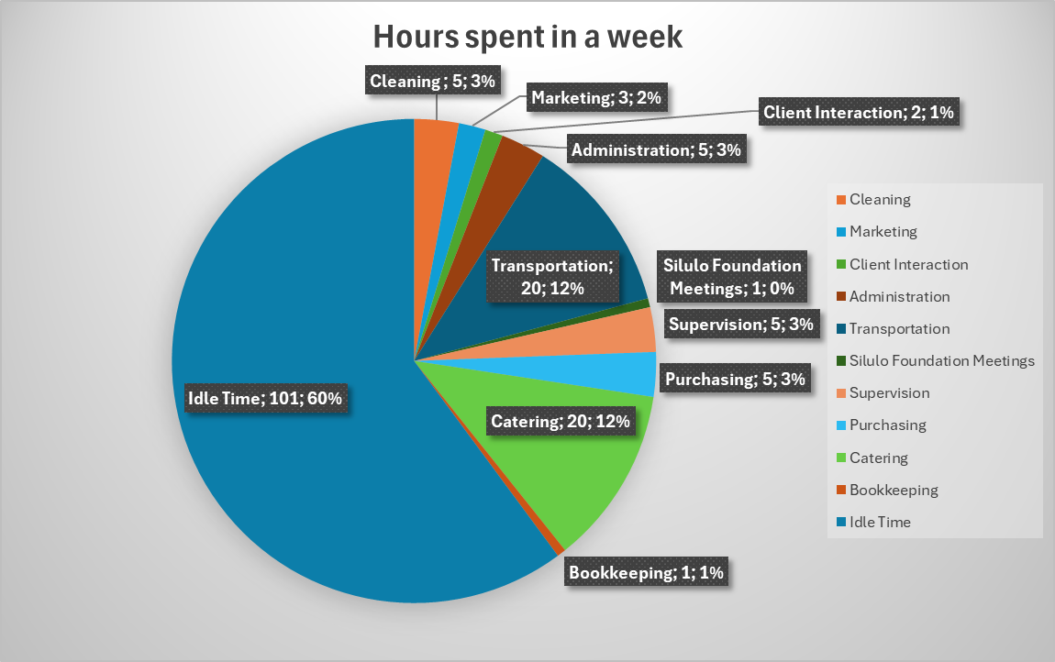

To explain the hours Mrs. Ndyalivani spends in her week (24*7=168 hours), we can look at the above pie chart to get an average view of the percentage of hours spent on business tasks in relation to total hours available. She spends 5 hours per week helping to clean up the food stations and eating area. One hour per week is required by the Silulo Foundation for training meetings which is rounded down to only 0% of her time. She spends on average 3 hours per week on marketing as her employees are mostly responsible for this function. She interacts with clients everyday for a few minutes which adds up to about 2 hours per week. She only spends 5 hours per week on admin as her husband is mostly in charge of administration. Transportation of 20 hours per week takes up a large amount of her time as it includes travelling to and from home, to the stores for restocking, to the campuses and to pick up and drop off her children.

Supervision of her employees takes about 5 hours per week as she checks up on them everyday. Purchasing of stock takes place everyday so it takes up about 5 hours per week. Catering is a huge part she focuses on in her business and spends roughly 4 hours per day on it, adding up to 20 hours per week. Mrs. Ndyalivani checks the books briefly when she gets the chance when she is at the restaurants but only thoroughly checks them every three months but aims to improve this to checking on a monthly basis. As it stands, she only does bookkeeping activities for 1 hour per week as her husband is responsible for the finances of the business. Her business time is idle for 101 hours in a week but this includes the needed family time, catching up on chores, cooking, personal hygiene, sleeping and other non-business related activities.

Conclusion
In conclusion, Woow Foods generates its income through a high-volume, cafeteria-based model focused on selling culturally familiar street foods like Gatsbys, Kotas, and Vetkoek. These items are sold daily at two CPUT campuses. Sales are tracked using POS systems and MTN MoMo, ensuring accurate reporting. To improve financial performance, Woow Foods should introduce combo packages pairing high margin items like Gatsby's and Kotas with drinks or vetkoek to increase average spending per customer. Delivery services for lecturers and nearby offices could convert missed foot traffic into consistent revenue, especially during exam periods when walk-ins drop. Ingredient sourcing, particularly for potatoes, should be optimized and casual labour scheduling refined to reduce variable costs. With strong profitability and a loyal customer base, Woow Foods is well positioned to grow, provided it strengthens operational efficiency and expands into new campuses or delivery platforms.

Woow Foods Deliverables & Implementation Plan
Category | Deliverable | Implementation Plan
Human Resources & Operations | Employee Registration | Develop a formal HR system where all employees are registered with basic details (ID, contracts, tax compliance, bank accounts). Use a standardized onboarding checklist.
Human Resources & Operations | Employee Contracts | Draft legally binding contracts covering duties, hours, wages, leave, and code of conduct. Contracts should be signed upon hiring and stored securely (digital + physical copies).
Human Resources & Operations | Employee Roles & Responsibilities Document | Create a detailed document outlining each role (chefs, cashiers, cleaners, supervisors). This will reduce confusion and improve accountability. Review quarterly as the business grows.
Human Resources & Operations | Business Leadership Hierarchy | Establish an organogram (Owner → Manager → Supervisors → Staff). Clearly define decision-making authority and reporting lines to streamline daily operations.
Branding & Marketing | Signage | Install professional signage at each CPUT cafeteria outlet for visibility. Ensure consistent branding (logo, colors, tagline). Use indoor menu boards and outdoor signs where possible.
Branding & Marketing | Social Media Presence | Revamp Woow Foods’ digital presence by updating operating hours, menu, and catering services. Maintain active posting (weekly specials, promotions, staff highlights). Assign one staff member or outsource to a social media manager.
Sales & Customer Engagement | Menu Revamp (Bulk Orders & Specials) | Update menu to include bulk options for students or lecturers and events. Introduce seasonal specials (e.g., Back-to-School Discounts, Exam-Season Combos) at fixed times annually to build a sales culture. Promote these via social media and posters in cafeterias.
Avuke group for compliance issues
Matt

